**M1054**

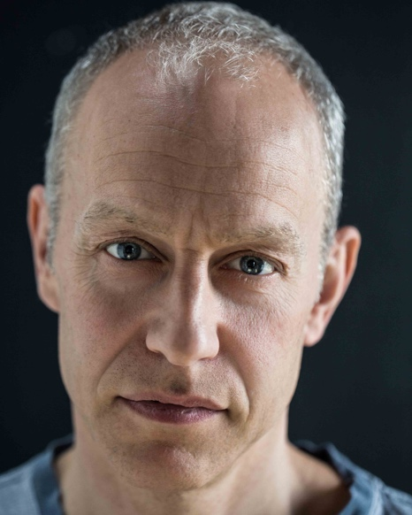

***Measurements and Body Details***

Height:  5’10 3⁄4 Hat: 59cm = 7 1⁄4 UK  
Collar:  16 1⁄2 Chest: 40    
Waist:   33 I/Leg: 31   
Shoe:  10   
Hair:  Fair/grey(short) Eyes: Blue   
Build:  Medium Tattoos: None   
Role Playing Ages: 35-45

Skills/Background

Full driving licence, salsa dancing, judo, American football, soccer to a good standard, rugby, athletics, tennis, good at most sports. Photography. Was in Army Reserve for 5 years with 1 tour working for the UN in Cyprus, experience using firearms, BSc in Computing.

***Training***

2013 – 11⁄2 year (part time) Acting for Film – Paul J Lane Acting School.   
2005 – 2 week course at RADA - ‘Skill Development through Shakespeare’   
Member of the Actors Centre with access to on going training.

Credits

***Stage*** *(Year, Type, Role, Production, Company, Director)*

2014, Play ,**Epikhodov**, The Cherry Orchard, Acting Gymnasium, James O'Donnell   
2005, Play, **Macduff**, Macbeth (outdoor production), South Hill Park, Bracknell. Richard Anscombe.

2004, Play, **Mr Shanks**, Habeous Corpus, The Windlehsam Theatre Company, Paul Sky   
2004, Play/Musical, Fab,Fab,Fab, **Narrator, soldier and chorus**, The Wilde Theatre- South Hill Park, Bracknell, Mark Rayment.   
2004, Musical, **Solo singer, Soldier, Can Can dancer, chorus**, Old Time Music Hall sketches, The Windlesham Theatre Company, Morrison Thomas.   
2004, Play, Daisy Pulls it Off, **School Master**, Act One Theatre Group - Licensed Victuallers Theatre, Bracknell.

***TV and Film*** *(Year, Film or Show Title, Role Type, Production Company, Director)*

2016 Pre Production, Film, Chronicles, **Danny MqQueen**, Film Coolio, Paul J Lane.   
2016 Pre Production, Film, Londinium, **Adam**, Film Coolio, Paul J Lane.   
2015 Short Film, The House in the Clouds, **Salesman**, Elektra Films, Joseph.   
2015 Film, The Singleton, **Father Flint**, Film Coolio, Paul J Lane.

2014 Film, 1603, **Armourer**, Film Coolio, Paul J Lane.   
2014 Film, Coolio, **Danny McQueen**, Film Coolio, Paul J Lane.   
2013 Internet Series, Time Travel Gangster Chronicles, **Danny McQueen**,Film Coolio, Paul J Lane.