**M1052**

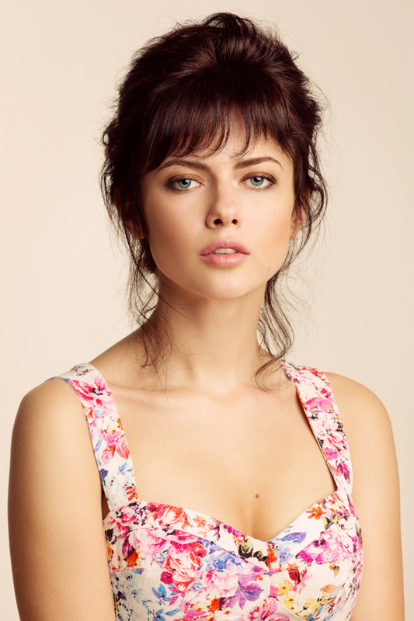

Height: 5’6” (168 сm)

Weight: 105.8 lbs (48 kg)

Color Hair: Brown

Color Eyes: Blue

Playing Range: 17-26  
  
FILM AND TV

*full list upon request; commercials also available upon request

Bartender…………………………… Featured……Art Pictures and White Media, Russia. Dir: Dina Sturmanova

Sunstroke ……......Episode……..Tri T Dir: Nikita Mikhalkov

The world for two…………. Supporting…………………………….….Dir: Natal’ya Srednikova

Forester..……………………………. Supporting….……………………..…………Dir: Victor Konisevich

A long road to home…………..Episode…………………………….Dir: Olga Dobrova-Kulikova

Kitchen.………………………….........Guest Star…………….……….…Dir: Dmitrii D’yachenko

TRAINING

Higher Theatre School named by Shepkin

Casting Workshops: Nancy Bishop (CSA) & Joel Kirby, Prague

Acting training studio: Pygmalion, Paris

Acting master classes: Ivanna Chubbuck, Moscow

SPECIAL SKILLS

Languages: Native in Russian; fluent in English and french, basic knowledge of Spanish, Italian,. Driver’s license – excellent driver; automatic. Singer – Alto, various styles. Horseback riding – beginner. Sports; serfing, streching