**M1248**

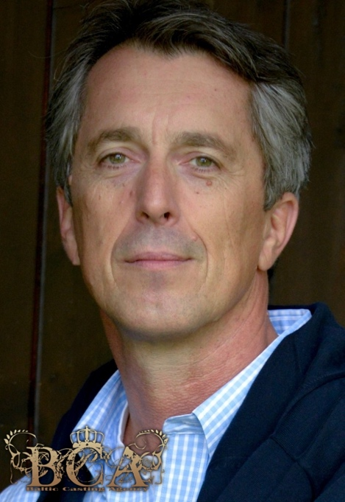

**Bookable from:  Germany, Austria or UK**Date of birth/playing age 15.9.1960 ( 45-59 years)   
**Residence:  London/UK, Munich/Germany, Vienna/Austria** Austrian Nationality: Austrian  
  
Height/Weight: 177cm / 75kg (5‘9“/165 lbs)    
Hair/Eyes:   dark brown-grey/brown-green   
Languages:  German (native), English (fluent), french (good/conversation)  
Sports: Skiing, Horse Riding   
  
**2. EXPERIENCE**

**Production Title Role When**

XXX Major US-Series under NDA under NDa 2015  
Bad Robot Mission Impossible Voice over 2015

Die Medienakademie Ernsthaft Sterben  Herr Hubenberger,the boss 2015  
ZDF/Eikon Media Unter Verdacht  Jens Viersen, govn. Official,(sup) 2014  
Iris/Majestic Prod. Colonia Dignidad Embassy staffer 2014  
ZDF/Wiedemann & B. 600PS fuer zwei  Businessman1 2014  
ZDF/If...productions Der Goldfisch Visitor1 (sup.) 2014  
ARD/TV60Film GmbH Polizeiruf 110 Smok Eigner’s lawyer (supp.) 2014  
Medienakademie M. Wiener Melange  Mikele,the cook (sup.) 2014  
ARD/Bavaria GmbH Sturm d. Liebe  Austrian doctor (supp.) 2014  
ARD/Tivoli Film Mord in bester Gesell Mr. Poplawsky - neighbour (supp.) 2013  
BR/Bayr. Fernsehen Dahoam is dahoam Mr. Zengler - businessm. (supp.) 2013  
Filmworks-Studio In the gallery Gallerist 2013  
Wiedemann & Berg Spiegelaffare Mr. Schloss-architect (supp.)  2013   
ARD/Bavaria GmbH Sturm d. Liebe Mr. Burghagen-businessm (supp.) 2012  
FH Salzburg Mutterliebe Münchner Arzt-doctor (pal) 2012

Sperl Productions Hochzeiten 2 Herr Zwetich/Concierge (supp.) 2012  
History TV Ltd. /BBC Hitler Project General. W. von Brauchitsch (sup.) 2012  
ZDF/Bavaria TV Herzflimmern  Dr.Stegmann, (pal.) 2012  
ARD-ORF/Teamworx Rommel  General v.Boineburg (sup.) 2011  
ZDF/Teamworx München `72  Kehat Shorr / (pall),7 shooting days 2011  
BR/Bayr. Fernsehen Dahoam is dahoam  Herr Simbach-businessm. (supp.) 2011  
James Bond Prod. A Quantum of Solace Quantum partyguest 2009  
Theatre: www.gugg.at  Supermarkt-Gel. Herr Aumeier (pal.) Nov.2012-Apr.2013  
Educational/Focus TV  Body Language Manager 2013  
Theatre  Can’t Giovanni 2015

**3. EDUCATION   
Title  School/Trainer When**Acting class  FederalMusic School, Austria/Claudia Schächl 2010-2013  
Scene-Analyses Performing Arts Studio, Munich/Suzanne Geyer 2014  
Camera-Acting/Meisner Training Filmwerkstatt Munich/ Jim Walker 2012

 