M1361

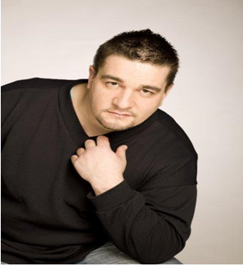

About me
I’m a multitalented man from Southern Finland. Father of five. An athlete, actor, model, sports masseur, personal trainer and also a multiple Finnish, European and world champion in bench pressing.
Measurements and other info

Height: 175 cm/ 5f 10”
Weight: 105 – 115 kg / 230 – 255lbs
(Depending if it’s competition season or not)
Sizes:
Jacket XXL/58-60
Bottom 38-40/32 XXL
Shoe size 43-44/8½ -9
Hair color Dark brown
Eye color Brown
Education Place of education

2012 Prostunt school Helsinki
2008 Trainer of the safety personnel Tampere
1996 Sports masseur, Personal trainer Tampere
1994 Security/safety person/bodyguard Hämeenlinna

Special skills

Marshall Arts, stunts, wrestling, Art Wushu, power lifting, athletics, playing drums, singing

Dance skills

Waltz, Tango, Foxtrot

Languages

Finnish, native
English, good
Swedish, satisfactory

