**M1724**

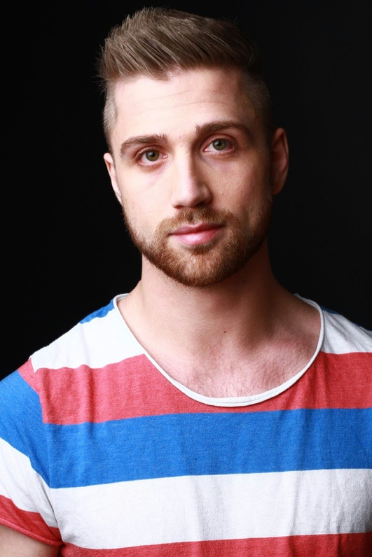

**Appearance**

Hair: Dark blonde (Straight)   
Acting age: 20 - 32   
Eye color: Mixed (green)   
Origin: Scandinavian   
Height: 178 cm (5’10”)   
Clothing size: Medium   
Shoe size: 42 EU   
Hat: 57   
Pants: W32 L32   
Weight: 75kg (165 lbs)   
  
**Language Experience**

Swedish  Native language   
English (American) Advanced   
English (British) Advanced

**Skills**

* Fighting & various martial arts (stage fighting / screen fighting)   
* Breakfalls   
* Medium height falls   
* Fire stunts   
* Physical acting (specialized in motion capture)   
* Rappelling   
* Visual act based 3D winch system operator, “SCAI 3D”   
* Ratchet & Wirework   
* Firearm handling   
* High Falls   
* Rigging   
* Precision driving   
* Acrobatics /Parkour/Freerunning   
* Horseback riding   
* Military knowledge, tactics, movement patterns   
* Various melee weapons (knives, swords, nun chucks, staff etc.)

**Education**   
Swedish Stunt group - 2007

**M i s c . I n f o r m a t i o n :** D r i v e r s L i c e n s e : B

**Resume**

**Production**  **Role Year**

Sameblod  Assistant Stunt Coordinator 2015  
Modus ( Tv­series)  Assistant Stunt Coordinator 2015  
Miss Peregrine's Home for Peculiar Children Winch system operator 2015  
M odus (Tv­series)   
Warhammer: The end times - Vermintide (Video Assistant Stunt coordinator 2015  
Game)Mo-cap Stunt performer 2014-2015  
Star wars: Battlefront (Video Game) Mo-cap Stunt performer 2014-2015  
The Circle (Feature film) Assistant Stunt coordinator 2014  
Wolfenstein: The old blood (Video Game) Mo-cap Stunt performer 2014-2015  
Morran & Tobias (Tv - Series)  Stunt coordinator 2014   
Dragon Age: Inquisition (Trailers)  Mo-cap Stunts performer 2014  
Escape Dead Island (Video Game) Mo-cap Stunts performer 2014  
Assassins Creed: Chronicles (Video Game) Mo-cap Stunts performer 2013-2015  
Mirrors Edge: Catalyst (Video Game) Mo-cap Stunt performer 2013-2015  
Just Cause 3 (Video Game)  Mo-cap Stunt performer 2013  
Mad Max: Fury road (Video Game)  Mo-cap Stunt performer 2011-2014  
Unity Tech Demo  Mo-cap Stunt performer 2013  
Wolfenstein: The new order (Video Game) Mo-cap Performer 2012  
Battlefield 4 (Video Game)  Mo-cap Stunt performer 2012-2013  
The last wolf of SS (Short)  Mo-cap Stunt performer 2011  
XCOM (Video Game)  Krausse (German officer) 2011  
Folkoteket (Tv -series)  Mo-cap Stunt performer 2011  
Hamilton - But not if it concerns your Stunt performer 2011  
daughter (Feature film) Stunts 2011  
Hellenius Hörna (Tv -series) Stunt Double Mikael Nyqvist 2011  
Niscayah - Live show  Hooligan  2011  
"Sanningen" (Short)  Rigger/coordinator  2011   
Bloodforge (Video Game)  Mo-cap Stunt performer 2011  
Comhem (commercial)  Rigger 2011  
Swedish Armed forces (commercial) Stunt performer  2011-2015  
Hövding test approvals Helmet tests 2011  
Isdraken (Feature Film)  Stuntcoordinator assistant 2011  
The Horror at MS Aurora (Video Game) Mo-Cap Stuntperformer 2011  
Asian Winter Games Kazakhstan Rigger / Operator 2011  
Oriflame (Commercial)  Stunt assistant/rigger 2010  
Syndicate (Video Game)  Mo-cap Stunt performer 2010  
Live event, Jaegermeister  Stunt performer 2010  
"Burning like a cigarette"  Stunt performer 2010  
"Heavy with Sleep"  Stuntrigger/Safety 2010  
Battlefield 3 (Video Game)  Mo-cap Stunt performer 2010-2011  
Battlefield Bad Company 2 (Video Game) Mo-cap Stunt performer 2009  
Commercial "Chinners"  "Chinner" 2009  
Rampljuset  Stuntassistant 2008  
Sony Ad  Stunt assistant 2008  
LG Viral Ad  Stunt performer 2008  
ICA Norway Ad  Rigg / safety 2008  
If Norway Ad  Rigg assistant 2008  
Star Wars: Threads of destiny  Stunt performer 2008  
Way of the blade Stunt performer 2008

Der Komissar und das Meer:An Einem Einsamen Ort Stunt performer 2007

   
**Resume**

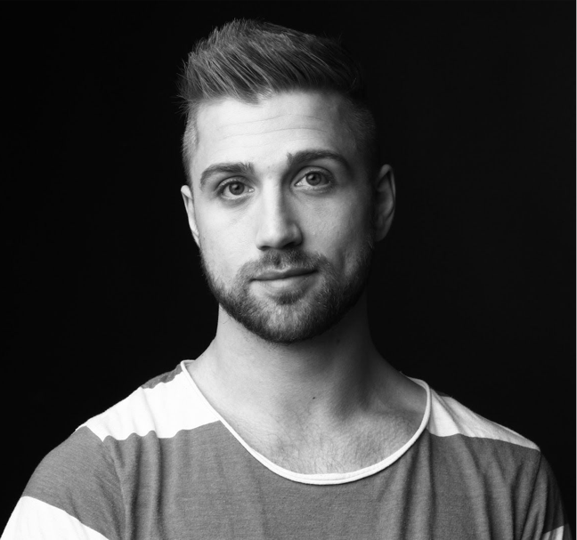 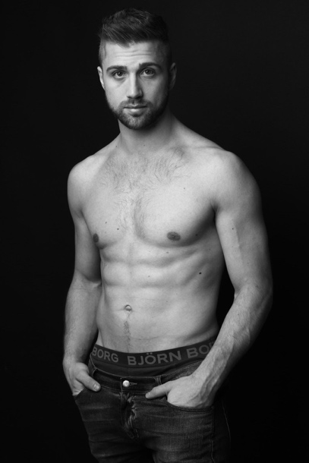

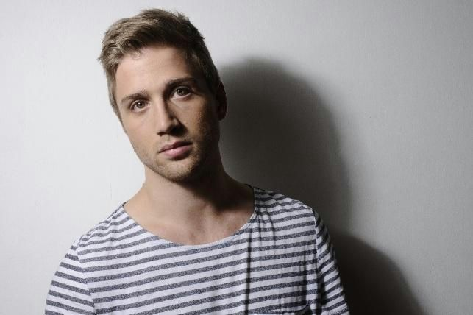

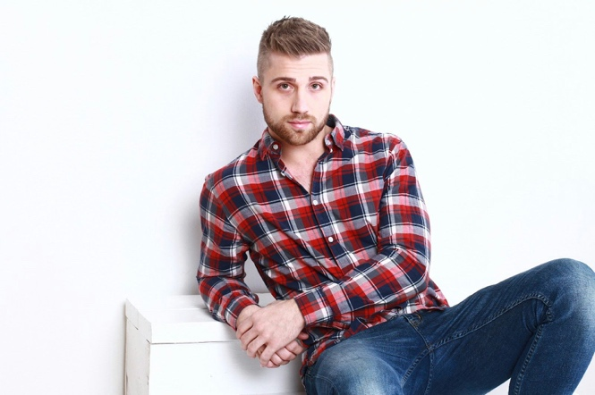 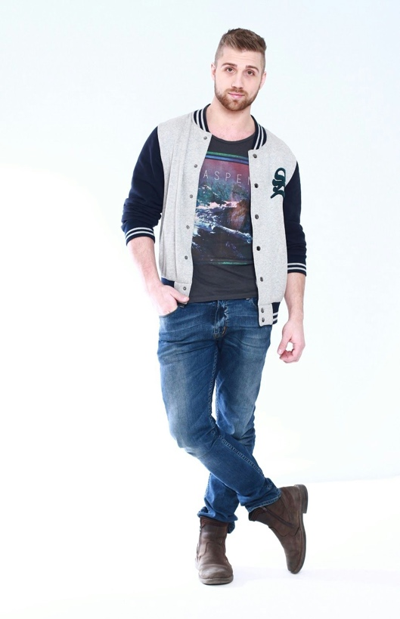

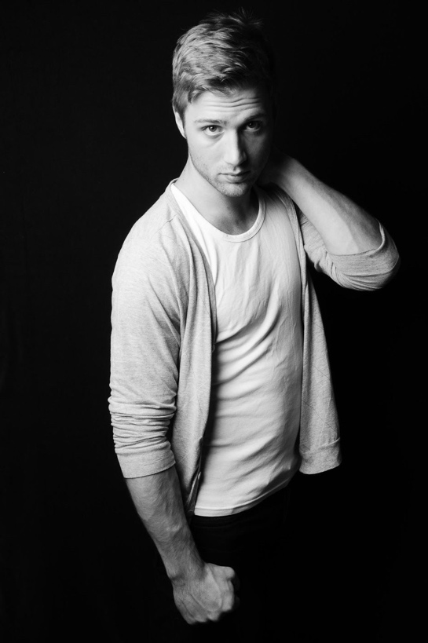 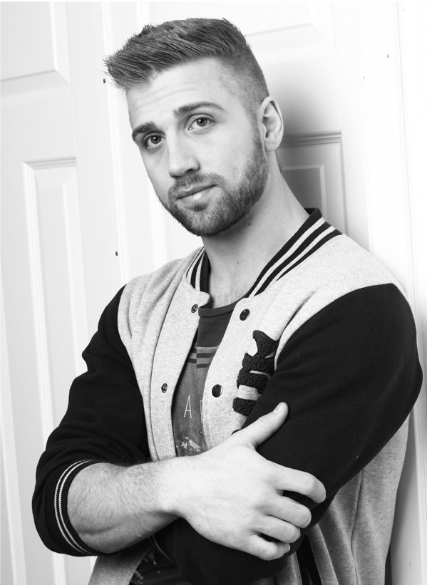

**Resume**Nicklas is Swedish actor and model.

He grew up in the southern parts of Sweden where he started acting and singing in a few musicals as a child. Eventually he moved to Stockholm where he started career as a stuntman and actor. Nicklas have a background in the Swedish armed forces, he is a martial artist, acrobat, musician, singer and he do improvised acting.

During the years Nicklas have specialized in motion capture, where you record the physical acting of a performer for a digital media such as video games. With almost 1400 hours of experience in a "mocap" suit alone, he is very used to taking and following specific directions.

Quote: “... *N* *ot only does Nicklas maintain an amazingly high level of fitness, he’s also an extremely passionate and determined performer. Nicklas will take the direction very seriously, listening intently and then bringing an unparalleled level of focus to ensure that even the most complex of motions can be nailed in as few takes as possible. He would also raise potential issues and propose viable solutions to problems. "*

­Jon Maine, Animation Director, Avalanche studios (For Mad Max the game)